./

Learning Report – Portfolio



|  |  |  |  |  |  |
| --- | --- | --- | --- | --- | --- |
| **Ver. Rel. No.** | **Release Date** | **Prepared. By** | **Reviewed By** | **Approved By** | **Remarks/Revision Details** |
| 1 | 31/01/2021 | Prathviraj  (99003123) |  |  |  |
| 2 |  |  |  |  |  |
| 3 |  |  |  |  |  |
|  |  |  |  |  |  |
|  |  |  |  |  |  |

**Document History**

Table of Contents

Course 1: SDLC 5

SDLC Mini Project: 5

CI/CD workflows for Project 5

Course 2: Core Java 6

Online Examination Mini Project: 6

GitHub Link: 7

Course 3: Advanced Python 8

Rock Paper Scissor Game: 8

GitHub Link: 8

Course 4: Data Analytics 9

Analysis of Complaints in New York Police Department: 9

GitHub link: 15

Course 5: TDLC 16

Basic Calculator Project with Test Cases: 16

GitHub Link: 16

Course 6: Robot Framework 17

1. Selenium: 17

Github Link: 18

2. Appium: 18

GitHub Link: 18

Course 7: Networking 19

1. Cisco Packet Tracer: 19

2. Wire Shark: 20

Table of Figures:

Figure 1: Medical store Management 5

Figure 2: Online Test 6

Figure 3: Test Result 7

Figure 4: Rock Paper Scissors 8

Figure 5: Cases in Particular time 9

Figure 6: Crime rate Map 10

Figure 7: Case status in each city 11

Figure 8: Cases in particular time 12

Figure 9: Case Status 12

Figure 10: Case status in each city 13

Figure 11: Types of cases 14

Figure 12: Types of cases in New York City 15

Figure 13; Test Cases For Calculator 16

Figure 14: TC 1 17

Figure 15: TC 2 17

Figure 16: Appium TC 1 18

Figure 17: 1 Router Configuration 19

Figure 18: 2 Router Configuration 20

Figure 19: Wire Shark 20

# Course 1: SDLC

## SDLC Mini Project:

In this course we made learning report of the mini project which we made in Step-in. The project consists of developing and implementing a Medical store management system that will automate all the process in a medical store. The developed system will reduce manual work that is required for keeping all the records of sellers and the customers. The system can able to provide any no. of repetitions and keep the record of the total customers.

This can also generate the bill for the customers.

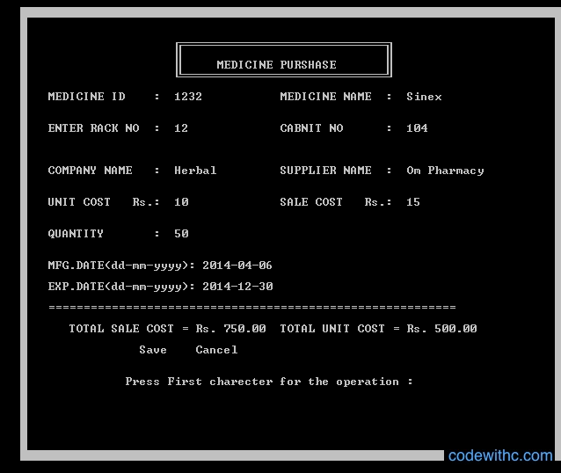

Figure : Medical store Management

### CI/CD workflows for Project

[Medical Store Management System](https://github.com/prithviwarrior/stepin105176.git)

# Course 2: Core Java

## Online Examination Mini Project:

This project is a mini exam conducting program which contains of 10 multiple choice question and options which concludes with the user shown the results as per the options selected.

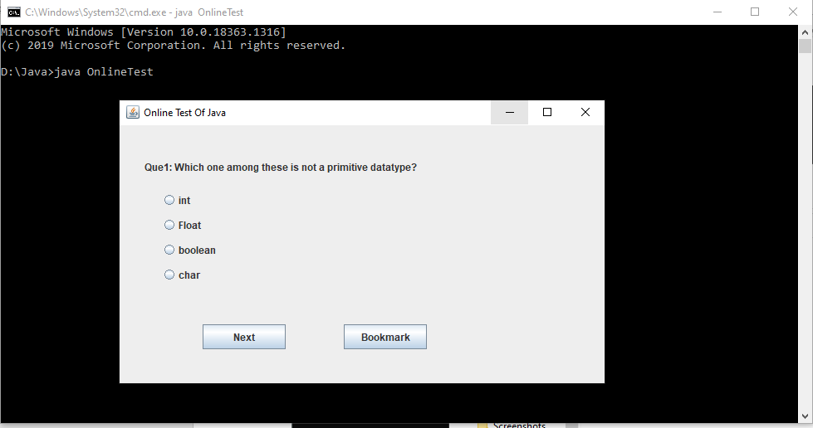

Figure : Online Test

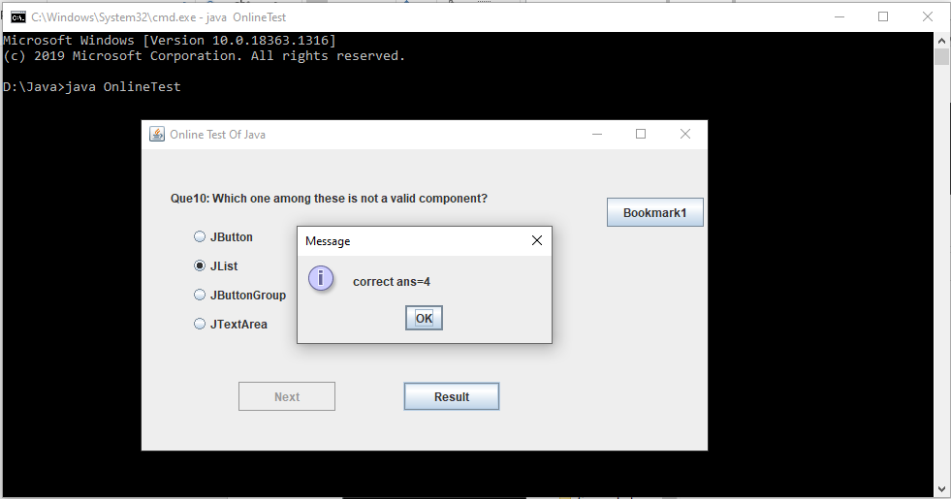

Figure : Test Result

### GitHub Link:

[Online Test](https://github.com/prithviwarrior/OnlineTest.git)

# Course 3: Advanced Python

## Rock Paper Scissor Game:

Here I have used List to select any of rock paper or scissors.

The computer uses the random value for list and selects winner if the Paper covers Rock or Rock smashes scissors or Scissors tears the paper. It will give the output as Tie if the both selects the same otherwise It displays that I lost the game.

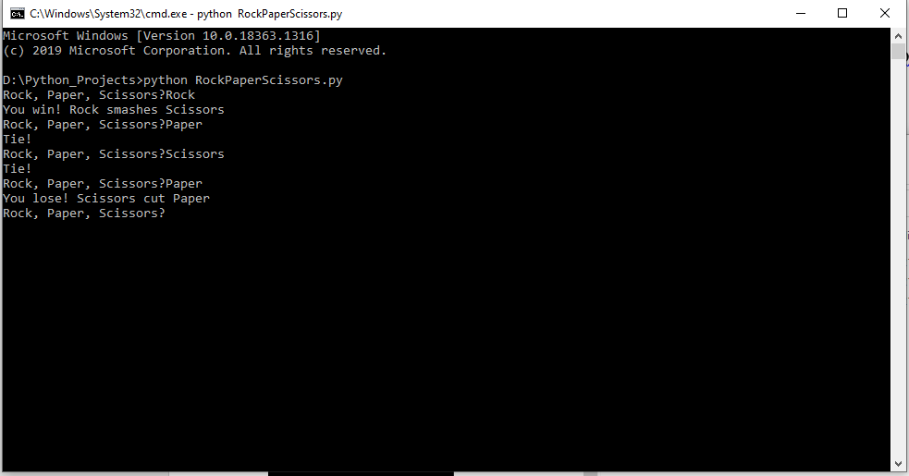

Figure : Rock Paper Scissors

### GitHub Link:

[Rock Paper Scissor](https://github.com/prithviwarrior/RPS_Game.git)

# Course 4: Data Analytics

## Analysis of Complaints in New York Police Department:

Here in this I tried to perform different operations with roughly 3 lac records in csv format.

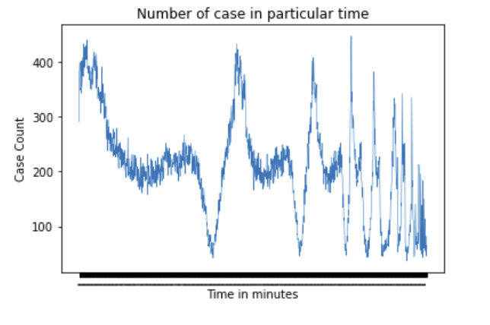How much better we can understand the data using pandas, numpy & matplotlib. Below are the screenshots of the plot.

Figure : Cases in Particular time

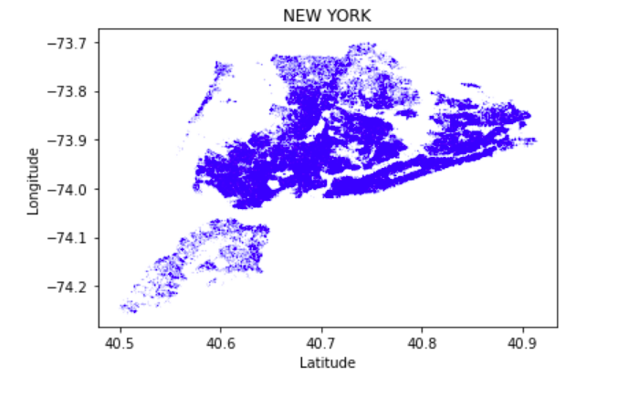

Figure : Crime rate Map

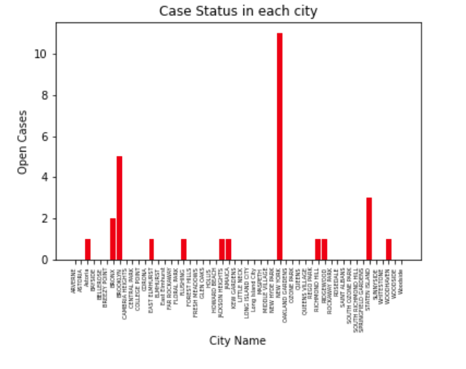

Figure : Case status in each city

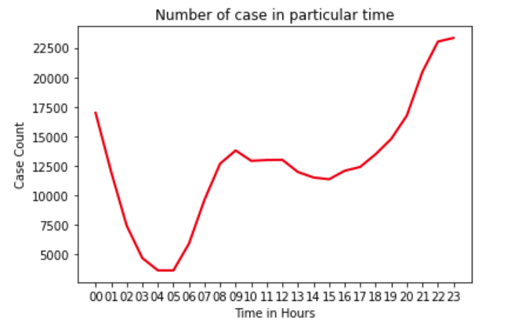

Figure : Cases in particular time

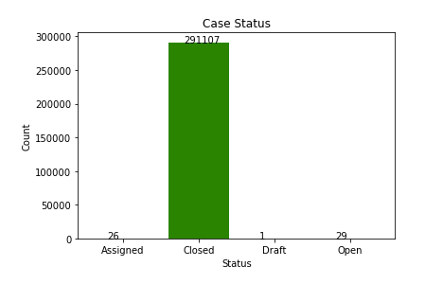

Figure : Case Status

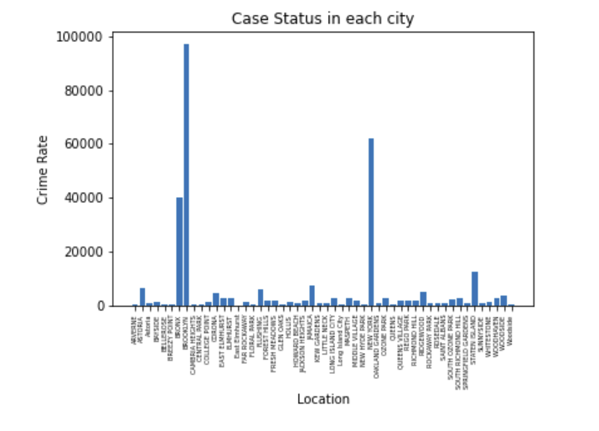

Figure : Case status in each city

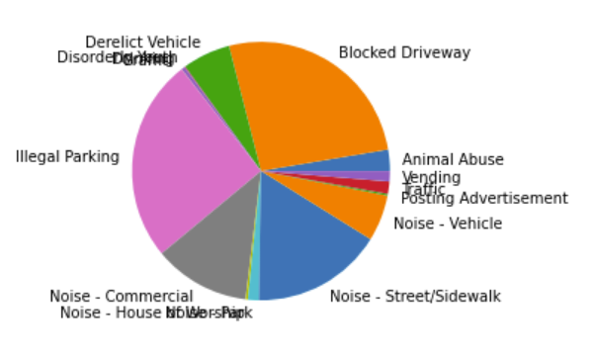

Figure : Types of cases

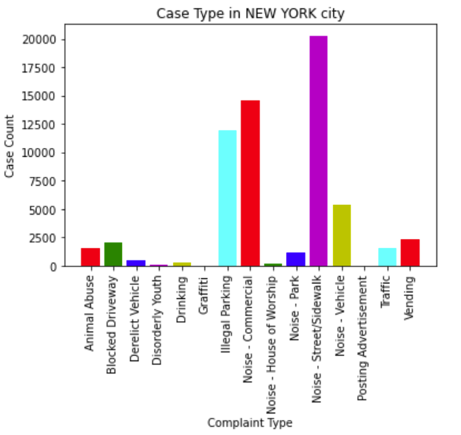

Figure : Types of cases in New York City

### GitHub link:

[DataAnalytics_With_Python](https://github.com/prithviwarrior/DataAnalytics_With_Python.git)

# Course 5: TDLC

## Basic Calculator Project with Test Cases:

In this first we made the test cases and then we had written the code. Below is the screenshot of the output.

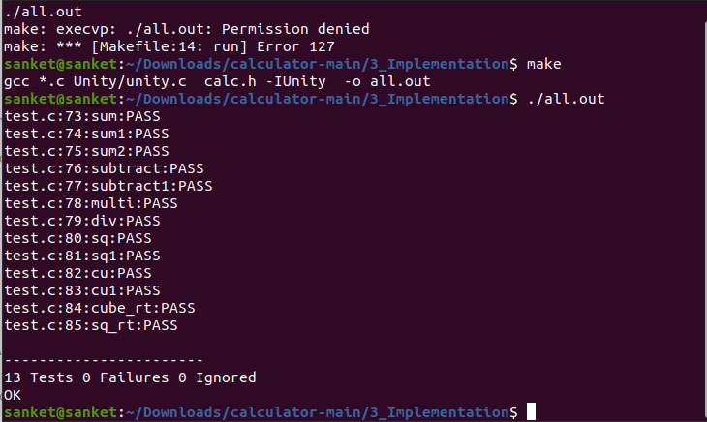

Figure ; Test Cases For Calculator

### GitHub Link:

[Calculator](%09https:/github.com/prithviwarrior/Genesis_TDLC.git)

# Course 6: Robot Framework

## Selenium:

In this I had made testcases for KOHLS website in which one fails and other pass. Below is the screenshot of the test cases.

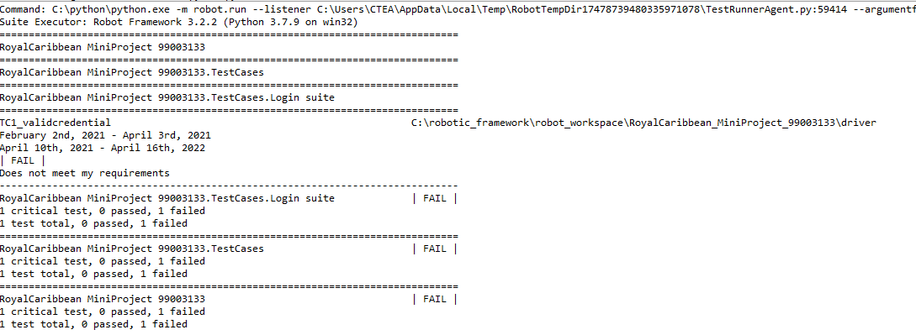

Figure : TC 1

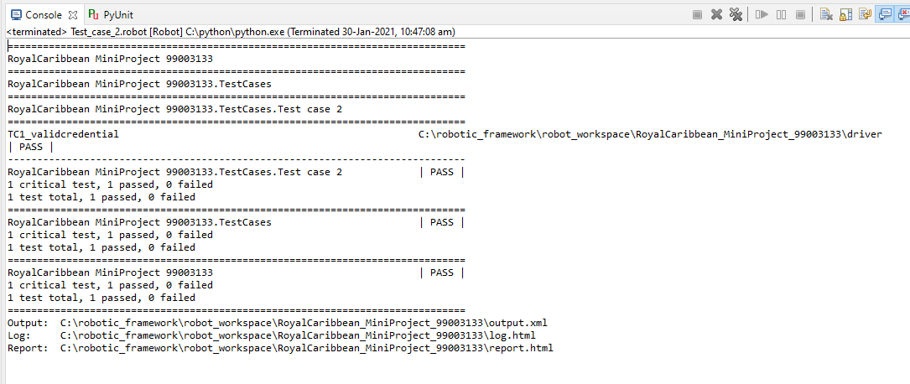

Figure : TC 2

### Github Link:

[Sellenium](%09https:/github.com/prithviwarrior/RobotFramework-99003123.git)

## Appium:

In Appium I had tested Carinfo app by adding some details of the car to the console. Below is the screenshot of the test case.

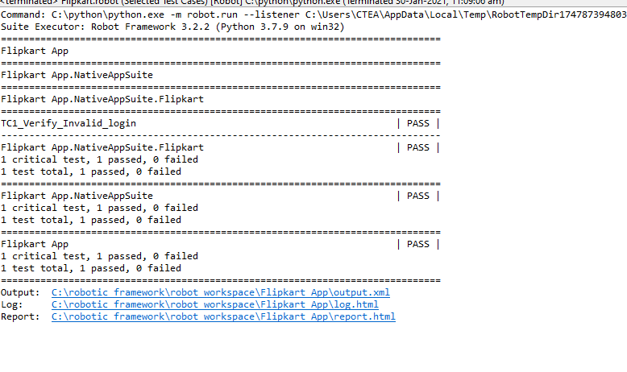

Figure : Appium TC 1

### GitHub Link:

[CarInfo](%09https:/github.com/prithviwarrior/Appium99003123.git)

# Course 7: Networking

## Cisco Packet Tracer:

In this software we had configure 1 router with Pc & 2 routers with Pc and tried to ping all of them. Below is the screenshot of the same.

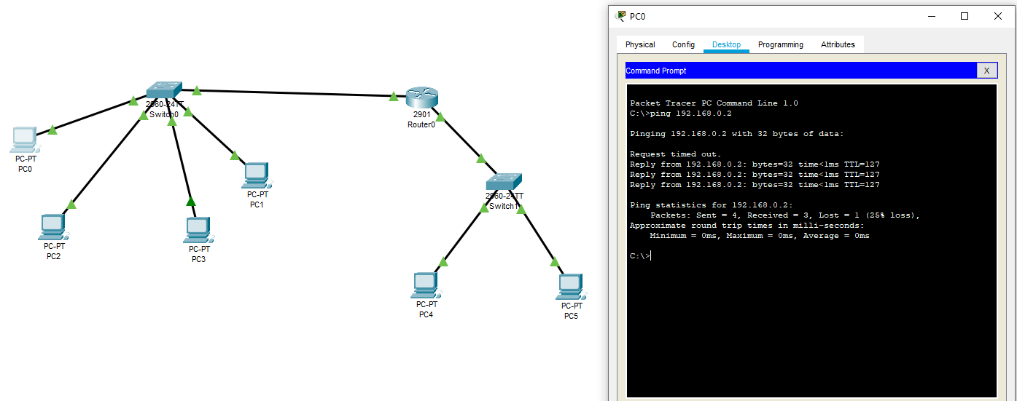

Figure : 1 Router Configuration

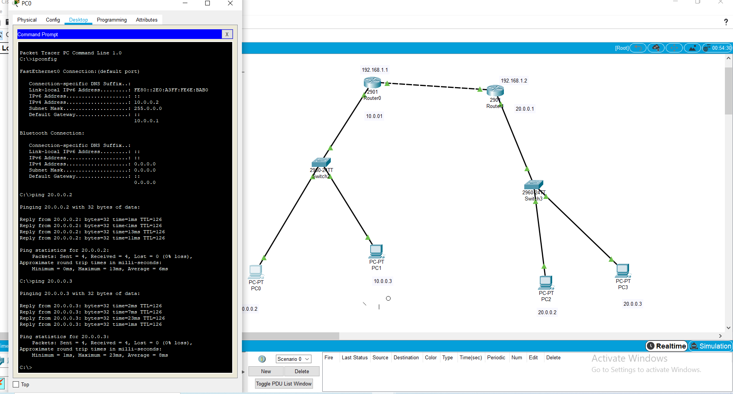

Figure : 2 Router Configuration

## Wire Shark:

Here we had ping [www.google.com](http://www.google.com) and seen how it’s happening at back end.

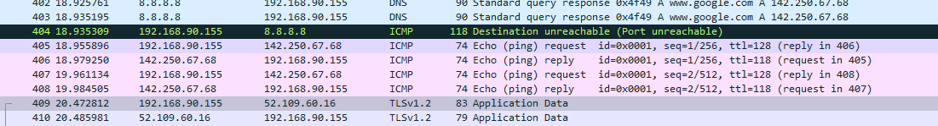

Figure : Wire Shark